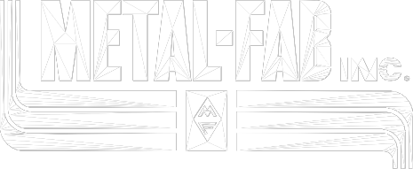
SAMPLE SPECIFICATION POSITIVE PRESSURE CHIMNEYS MODEL PIC

Furnish double-wall, factory-built, positive-pressure chimney which conforms to the requirements of NFPA-211. Products shall be listed to UL-103 for pressures up to 60- inch water column and temperatures up to 1400º F continuously.

The inner wall shall be constructed of .035” thick type 304 stainless steel for diameters
6” through 36” and .048” thick for diameters 38” through 48”.

Optional: The inner wall shall be constructed of .035” thick type 316 stainless steel for diameters 6” through 36” and .048” thick for diameters 38” through 48”.

The outer wall shall be constructed of .024” thick aluminized steel for sizes 6” through
24” and .034” thick for sizes 26” through 48”.

Optional: The outer wall shall be constructed of type 304 or 316 stainless steel, .024”
thick for all sizes.

Chimney shall incorporate a 1" insulating air space between the inner and outer wall.

All roof penetrations, terminations, appliance adapters, drain fittings, expansion joints required shall be supplied as products as a single manufacturer. When an induced draft fan or barometric damper is to be utilized with the chimney, the chimney manufacturer shall provide the necessary adapters or fittings to enable the installation of the fan or damper.

Roof penetration pieces shall be UL listed products of the chimney manufacturer. Where roof is pitched (up to 12 :12), roof penetration pieces shall be of the pitched type so that it is not necessary to provide a horizontal roof curb.

All inner pipe joints shall be held together by means of formed vee bands and sealed with P077 Silicone Sealant for flue gas temperatures up to 600º F, or P071 High Temperature Sealant for flue gas temperatures over 600º F.

Chimney exposed to weather shall be protected with one base coat and one finish coat of heat resistant paint or outer wall shall be stainless steel. Paint shall be furnished and applied by installer.

Chimney shall be installed in accordance with manufacturer’s installation instructions, UL
Listing and state or local codes.

L1609-10/02
7025

